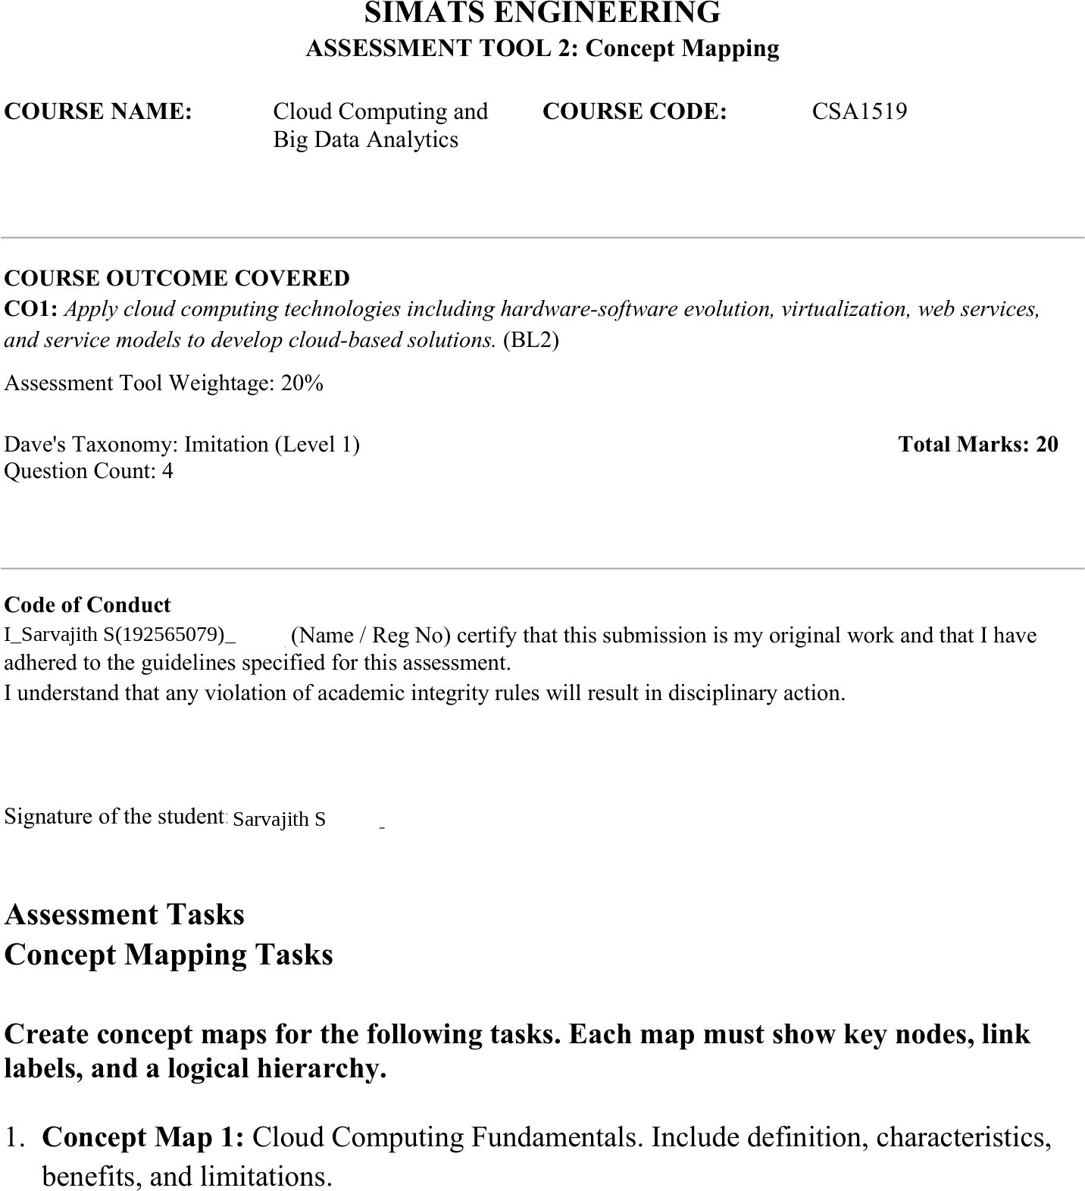

Concept Map 1: Cloud Computing Fundamentals

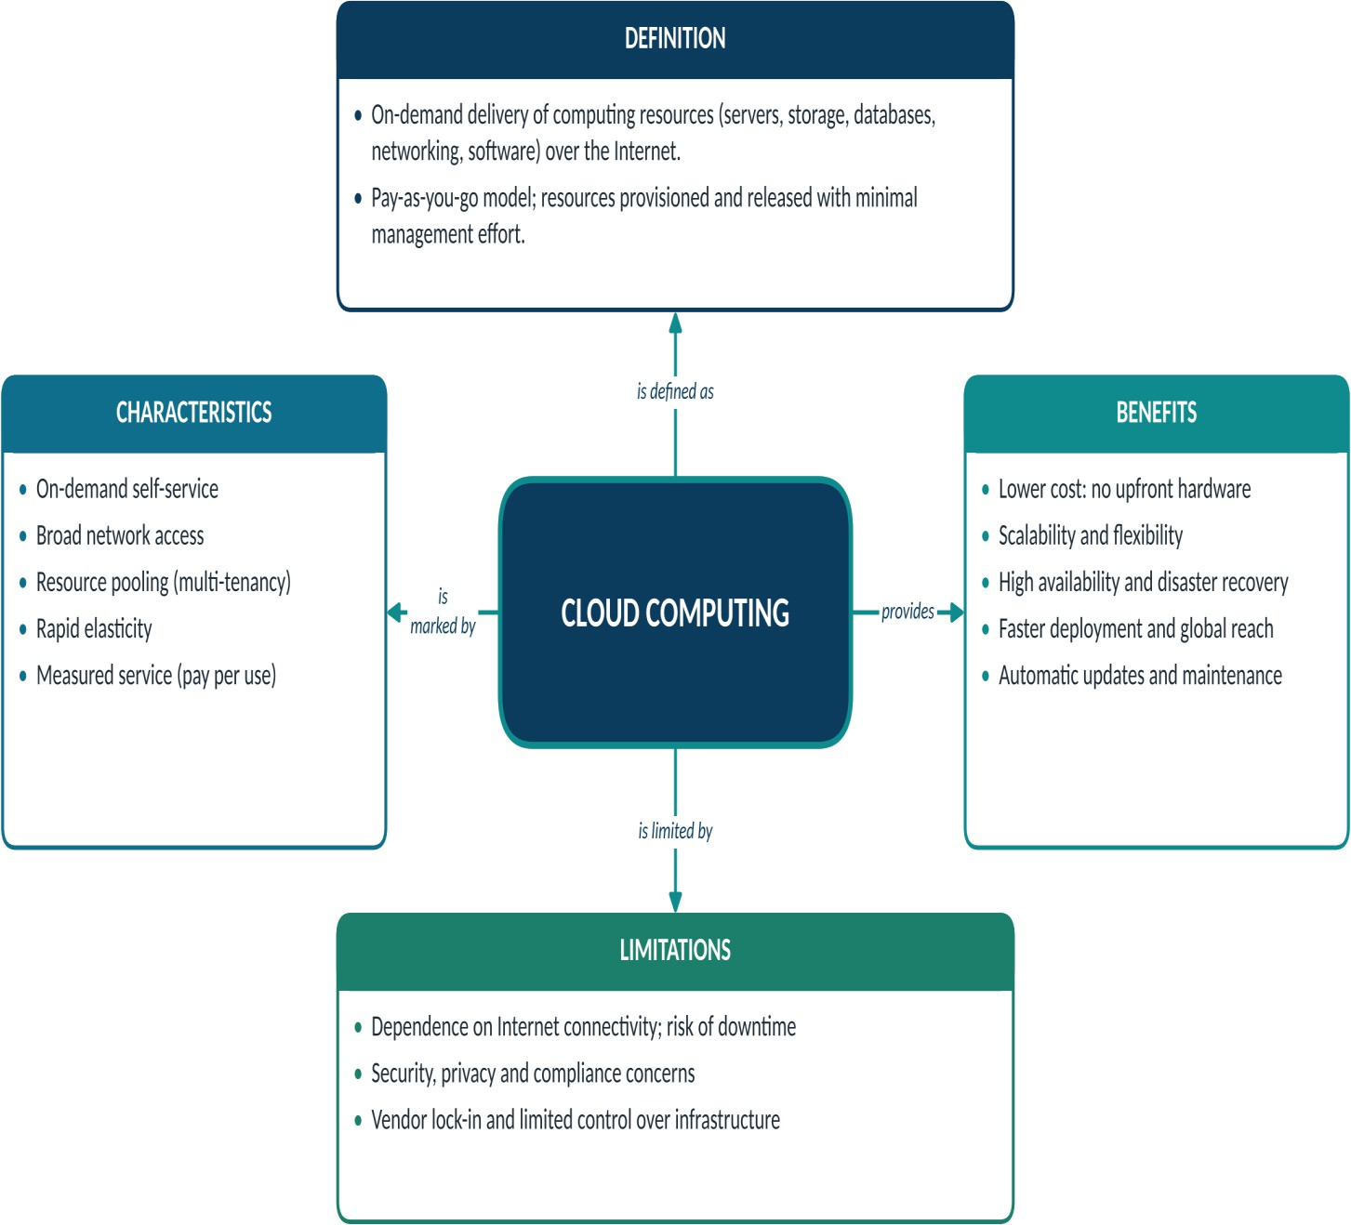

Concept Map 2: Evolution of Cloud Computing

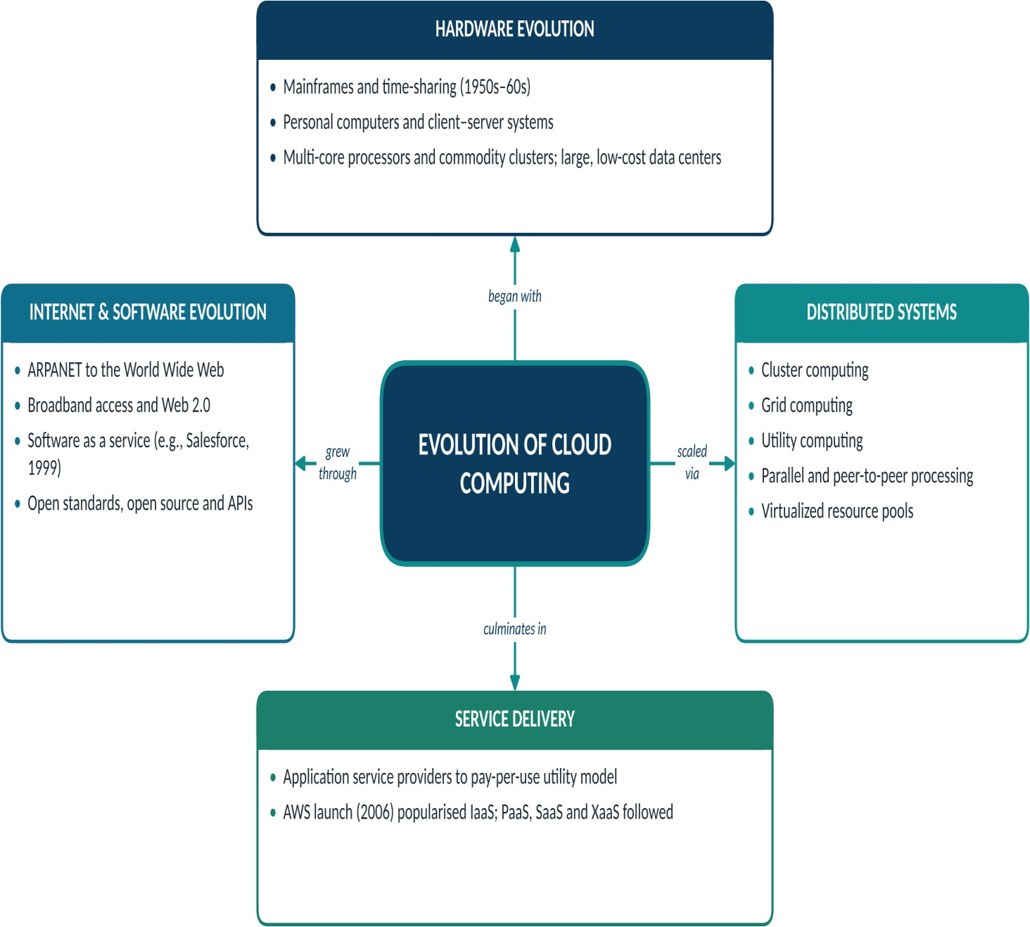

Concept Map 3: Service Models

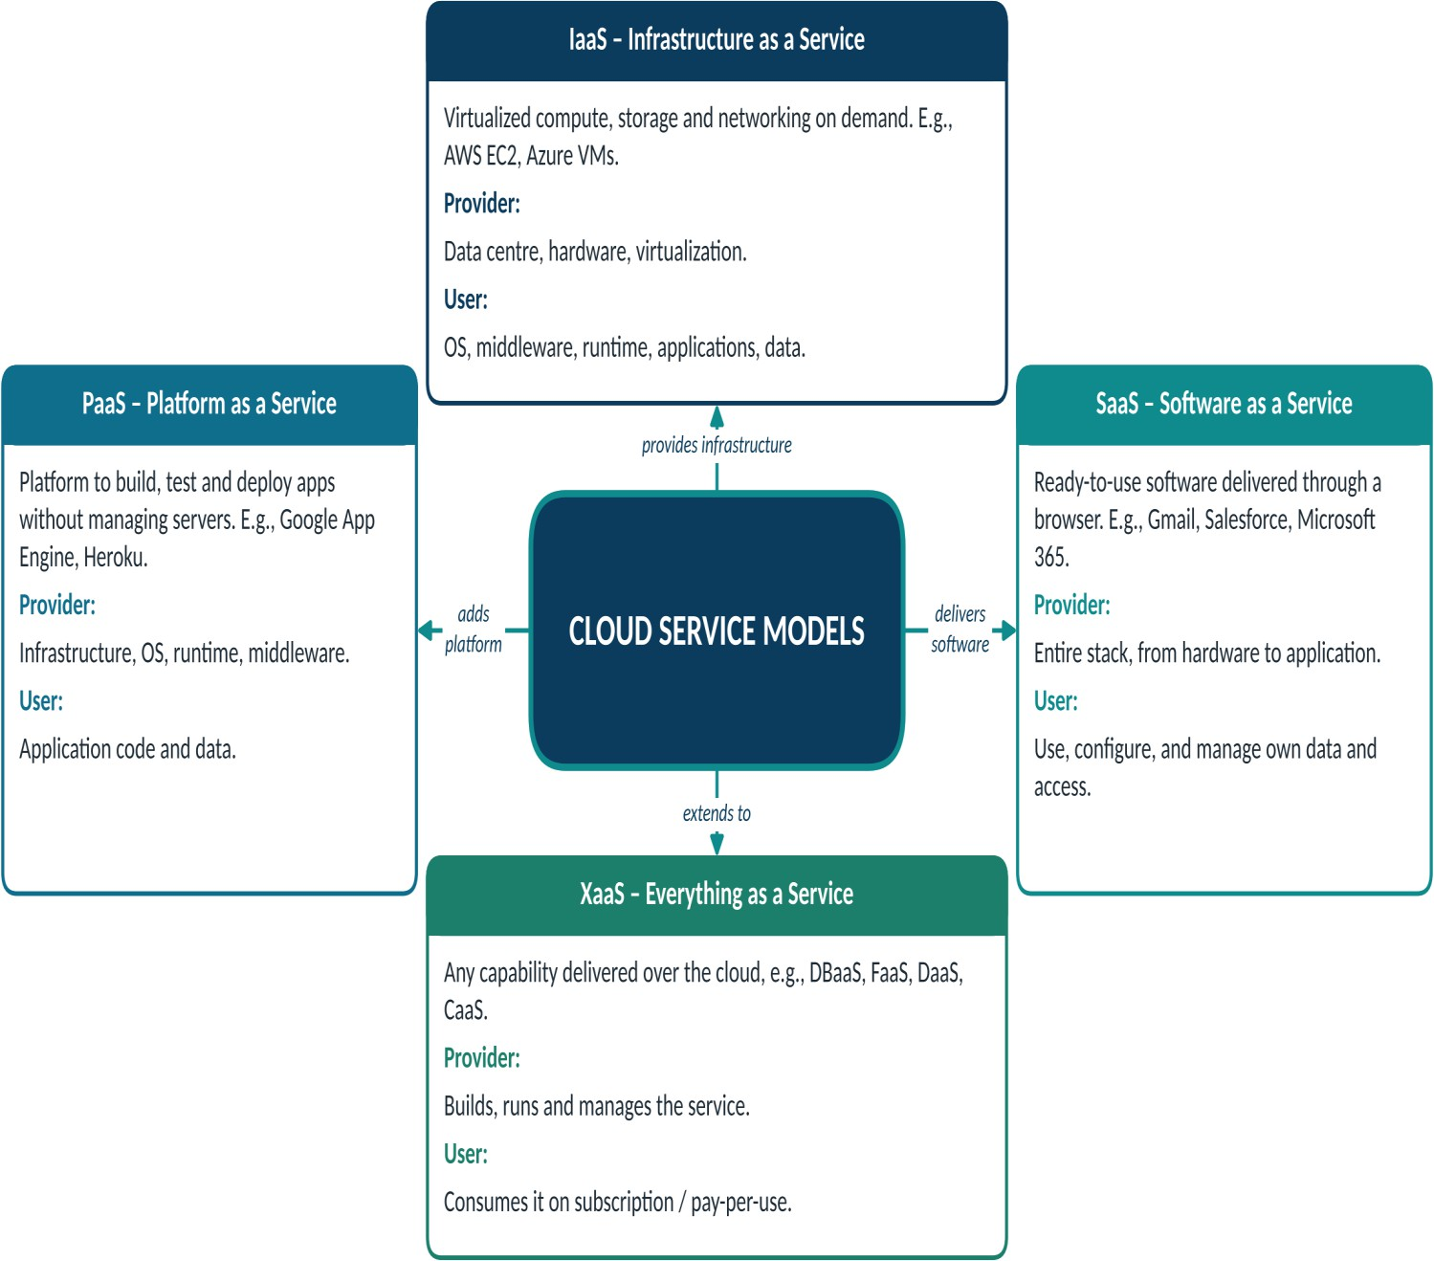

Concept Map 4: Virtualization and Web Services as Enablers of Cloud

